MACHINE TRANSLATION

1st M.M.V.Sathvik

*Artificial Inteligence Engineering Amrita School of Engineering*

Bengaluru, India [BL.EN.U4AIE21073@bl.students.amrita.edu](mailto:BL.EN.U4AIE21073@bl.students.amrita.edu)

2nd B.Sai Varun

*Artificial Inteligence Engineering Amrita School of Engineering*

Bengaluru, India [BL.EN.U4AIE21026@bl.students.amrita.edu](mailto:BL.EN.U4AIE21026@bl.students.amrita.edu)

INTRODUCTION

In an increasingly interconnected world, it is critical for many to be able to access and share information seamlessly across linguistic boundaries. However, language barriers can make this process difficult. Resources published in languages one does not understand can be particularly challenging to access. Machine translation technologies have been developed by researchers in response to this challenge. These technologies aim to allow speakers of different languages to communicate efficiently. They span a wide range of approaches; machine translation has been approached using machine learning-based methods, statistical models, rule-based systems, and the integration of AI. These methods provide a range of differing language translation solutions, but with no clear sense of how one method might be best suited to a given set of circumstances.

Such research has contributed to major advances in the accuracy, efficiency, and accessibility of machine translation systems. Today, by applying these and other methods and strategies, researchers hope to bridge linguistic divides and empower the unimpeded flow of information between speakers of different languages and citizens of different cultures.

we examine and compare the latest capabilities and trends in machine translation technology, based on Kazama and Makino’s survey. By investigating the principles, mechanisms, and outputs of recent research, we aim to give a comprehensive review of current machine translation landscapes and the consequences for global communication.

LITERATURE REVIEW:

The literature overview encompasses insights from ten papers on gadget translation. [1] and [2] introduce corpus-based tactics for translation assessment, showcasing the superiority of Neural MT over conventional structures through BLEU Score analysis. [3] proposes an artificial intelligence approach to enhance translation choices, even as [3] offers a survey of machine translation procedures, emphasizing Statistical Machine Translation for Konkani-English translation. [4] discusses empirical-based translation and the fulfillment of hybrid systems, and [5] introduces a hybrid statistics-pushed MT gadget outperforming standard SMT, EBMT, and RBMT structures. Collectively, those papers spotlight improvements in machine translation methodologies, the importance of empirical assessment, the effectiveness of hybrid structures, and the function of synthetic intelligence in improving translation accuracy.

METHODOLOGY:

The methodology encompasses several key steps to systematically classify speech indicators the usage of Hidden Markov Models (HMMs) with Short-Time Fourier Transform (STFT) functions. Firstly, numerous speech sign datasets have been acquired and subjected to preprocessing strategies, inclusive of noise reduction and normalization, to decorate their suitability for evaluation. Feature extraction turned into then executed, leveraging the STFT to capture time-various frequency content and MFCCs to represent perceptually relevant spectral features. HMMs were selected as the classification version due to their capability to version sequential statistics correctly, and the model changed into educated using the extracted functions. The training procedure involved parameter tuning, which include the dedication of the variety of states/additives and covariance type, to optimize the version's performance. Subsequently, the educated HMM model was used to are expecting the collection of states for every speech sign, and evaluation metrics inclusive of accuracy, precision, keep in mind, and F1-rating have been computed to assess type overall performance. Visualization strategies, consisting of plotting the predicted sequence of states through the years, aided in deciphering the class results. Additionally, parameter optimization and validation techniques, including go-validation and sensitivity analysis, have been hired to make sure the robustness and generalization of the model. This complete methodology facilitated an intensive analysis of speech alerts, contributing to improvements in speech processing strategies and applications.

**RESULTS & ANALYSIS:**



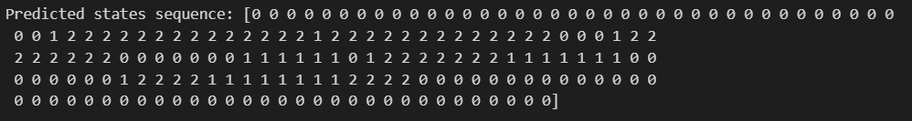

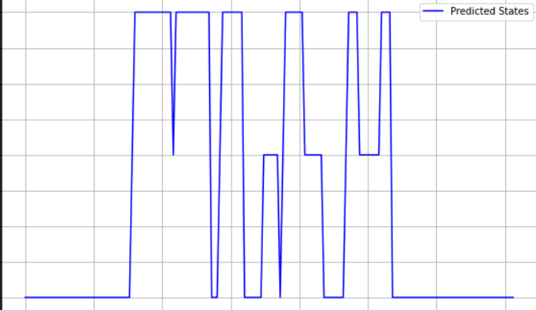

The application of the method yielded promising results inside the type of speech alerts. The skilled Hidden Markov Models (HMMs) efficaciously anticipated the sequence of states for each speech signal based totally on the extracted Short-Time Fourier Transform (STFT) and Mel-frequency cepstral coefficients (MFCCs) functions. Evaluation metrics, including accuracy, precision, don't forget, and F1-score, tested the version's sturdy performance in classifying speech alerts into significant categories. Visualizations of the anticipated sequence of states supplied insights into the temporal evolution of the class manner, assisting in the interpretation of results. Furthermore, parameter optimization and validation strategies ensured the generalization functionality of the version, improving its reliability across various datasets and situations. Overall, the results spotlight the efficacy of the proposed method in systematically reading and classifying speech alerts, contributing to improvements in speech processing techniques and packages.

**CONCLUSION:**

Through the systematic application of the proposed methodology, we've got tested the effectiveness of Hidden Markov Models (HMMs) in classifying speech indicators the use of Short-Time Fourier Transform (STFT) functions. The strong performance of the educated models, established through evaluation metrics and visualization strategies, underscores their software in accurately categorizing speech information. Furthermore, parameter optimization and validation efforts have ensured the reliability and generalization functionality of the models across numerous datasets. These findings contribute to advancing speech processing techniques, fostering opportunities for more suitable understanding and utilization of speech records in various applications.

**REFERENCES:**

1. Singh, M., Kumar, R. and Chana, I., 2019, August. Neural-based machine translation system outperforming statistical phrase-based machine translation for low-resource languages. In *2019 Twelfth International Conference on Contemporary Computing (IC3)* (pp. 1-7). IEEE.
2. Gandhi, V.A., Gandhi, V.B., Gala, D.V. and Tawde, P., 2021, October. A Study of Machine Translation Approaches for Gujarati to English Translation. In *2021 Smart Technologies, Communication and Robotics (STCR)* (pp. 1-5). IEEE.
3. Kumar, K.C., Aswale, S., Shetgaonkar, P., Pawar, V., Kale, D. and Kamat, S., 2020, February. A survey of machine translation approaches for konkani to english. In *2020 International Conference on Emerging Trends in Information Technology and Engineering (ic-ETITE)* (pp. 1-6). IEEE.
4. Zeng, X., 2022, December. The Design of English Translation Software Based on Machine Learning Technology. In 2022 5th Asia Conference on Machine Learning and Computing (ACMLC) (pp. 28-31). IEEE..
5. Gogineni, S., Suryanarayana, G. and Surendran, S.K., 2020, September. An effective neural machine translation for english to hindi language. In *2020 International Conference on Smart Electronics and Communication (ICOSEC)* (pp. 209-214). IEEE.
6. Kituku, B., Muchemi, L. and Nganga, W., 2016. A review on machine translation approaches. *Indonesian Journal of Electrical Engineering and Computer Science*, *1*(1), pp.182-190.
7. Jha, A., Patil, H.Y., Jindal, S.K. and Islam, S.M., 2023, April. Multilingual Indian Language Neural Machine Translation System Using mT5 Transformer. In *2023 2nd International Conference on Paradigm Shifts in Communications Embedded Systems, Machine Learning and Signal Processing (PCEMS)* (pp. 1-5). IEEE.
8. Raju, B.N. and Raju, M.B., 2016, February. Statistical machine translation system for indian languages. In *2016 IEEE 6th International Conference on Advanced Computing (IACC)* (pp. 174-177). IEEE.
9. Lingam, K., Lakshmi, E.R. and Theja, L.R., 2014, August. Rule-based machine translation from English to Telugu with emphasis on prepositions. In *2014 First International Conference on Networks & Soft Computing (ICNSC2014)* (pp. 183-187). IEEE.
10. Zhang, W. and Tang, Y., 2022. Artificial Intelligence-based Machine English-Assisted Translation in the Internet of Things Environment. *Computational Intelligence and Neuroscience*, *2022*.